Student app
Step 1: Create a project folder
mkdir student-app
cd student-app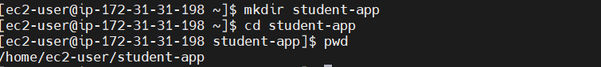
Step 2: Initialize Git
git init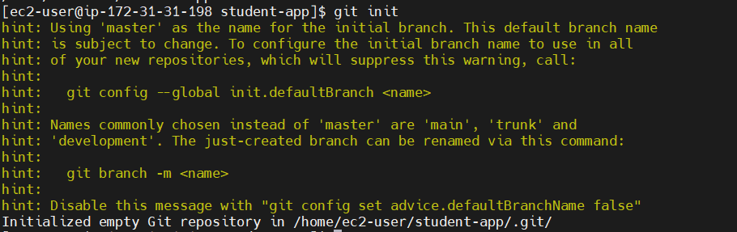
Example: You want Git to start tracking the student-app project.

Step 3: Create a file
echo "Welcome to Student App" > index.html

Step 4: Check the status
git status 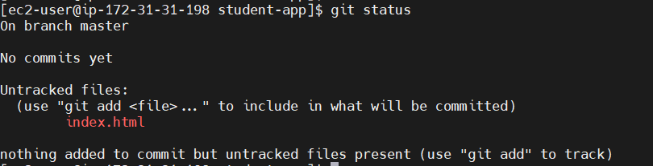

Output:
Untracked files:
index.html

Step 5: Add the file and Check the status again
git add index.html
or
git add .
git status

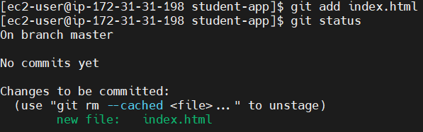

Step 6: Commit the file
git commit -m "Added index.html"
Output:
1 file changed
create mode 100644 index.html

Step 8: View commit history
git log
Author: Satish 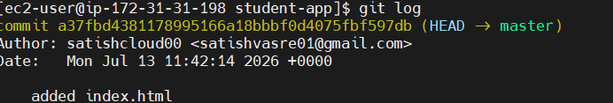

Step 9: Create a GitHub repository
Example repository:
student-app 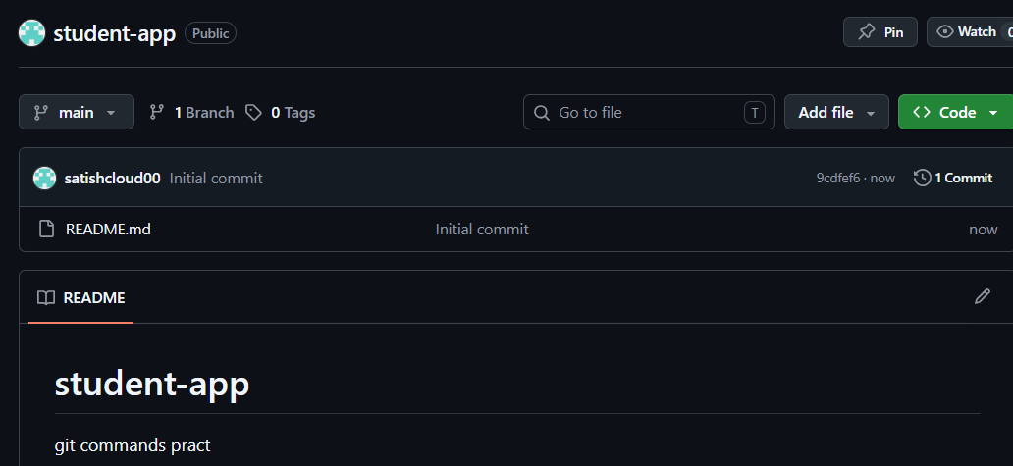

Step 10: Connect your local project to GitHub
git remote add origin https://github.com/username/student-app.git
Check the remote:
git remote -v 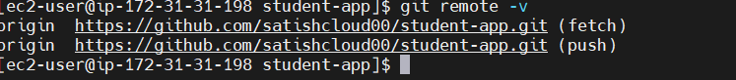

Step 11: Push to GitHub
git push -u origin main
Now your project is uploaded to GitHub. 